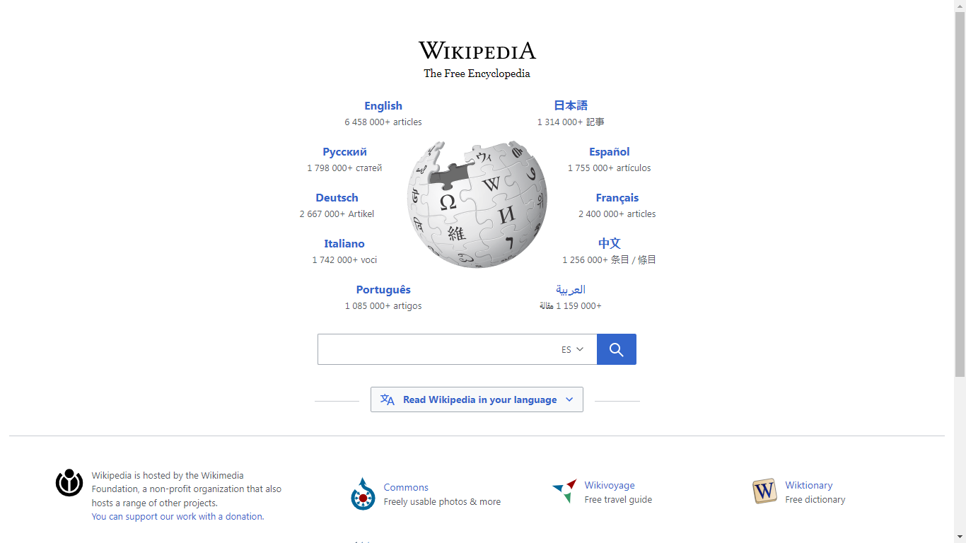

Fuente de WIKIPEDIA

The Free Encycolpedia

*Times New Roman*

Otro texto: Calibri (Cuerpo)

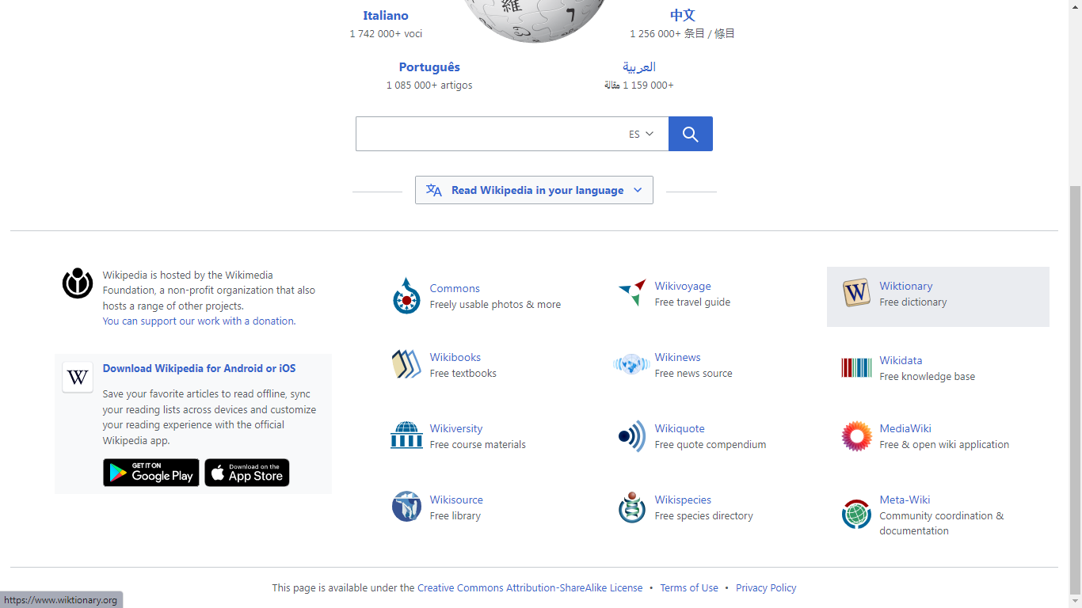

Dentro de las dos cajas

Responsivo:

1. Flex-direction column;
2. Flex-wrap: wrap;

Enlaces de imagenes

1: <https://encrypted-tbn0.gstatic.com/images?q=tbn:ANd9GcTLYhTPMz94GjYsXk3Ht1b0uSDJVvEuy80U0Q&usqp=CAU>

2: <https://w7.pngwing.com/pngs/95/679/png-transparent-wikipedia-logo-wikimedia-commons-wikimedia-project-computer-icons-disinfect-angle-text-trademark.png>

Commons: <https://upload.wikimedia.org/wikipedia/commons/2/23/Commons-logo-Anaglyph.svg>

Voyage: <https://upload.wikimedia.org/wikipedia/commons/d/dd/Wikivoyage-Logo-v3-icon.svg>

wikionary: <https://upload.wikimedia.org/wikipedia/commons/thumb/c/c3/Wiktfavicon_en.svg/1024px-Wiktfavicon_en.svg.png>

wikibooks: <https://w7.pngwing.com/pngs/228/268/png-transparent-wikibooks-wikimedia-foundation-wikimedia-commons-english-internet-explorer-miscellaneous-blue-angle.png>

wikinews: <https://e7.pngegg.com/pngimages/142/526/png-clipart-wikinews-logo-asia-wikimedia-foundation-wikipedia-asia-globe-logo.png>

wikidata: <https://upload.wikimedia.org/wikipedia/commons/thumb/6/67/Notification-icon-Wikidata-logo.svg/768px-Notification-icon-Wikidata-logo.svg.png>

wikiuniversity: <https://upload.wikimedia.org/wikipedia/commons/thumb/9/91/Wikiversity-logo.svg/1280px-Wikiversity-logo.svg.png>

mediawiki: <https://upload.wikimedia.org/wikipedia/commons/d/dd/MediaWiki-2020-installer-icon.svg>

wikisourse: <https://upload.wikimedia.org/wikipedia/commons/4/4c/Wikisource-logo.svg>

wikispecies: <https://upload.wikimedia.org/wikipedia/commons/d/df/Wikispecies-logo.svg>

meta-wiki: <https://upload.wikimedia.org/wikipedia/commons/0/0a/Meta-Wiki_Administrator.svg>